Welcome!

Your beautiful dog has been accepted into the playschool and we will do everything in our power to keep them safe, help them socialise and enjoy their time with our family.

We would personally like to thank you for choosing to join the Mocha and Maisy Playschool.

Mocha and Maisy Kemble strives to become a 5* rated business within the doggy playschool community. All employees of Mocha and Maisy are DBS checked and have Doggy First Aid training as a minimum, but we are aiming for higher standards and will train all play leaders to a minimum Level 3 Ofqual Care, Behaviour and Welfare Award and an ongoing education programme.

If your dog attends another doggy day-care centre a minimum of 3 days is required before they can come back to Mocha and Maisy. This is to reduce the risk of cross contamination of infection(s) being brought onto our site and protect our doggies as best we can from infections.

Please follow us on Facebook: @mochaandmaisy and Instagram: mochaandmaisydoggyplayschool and if you have ticked the box for us to take photos, we will be posting our doggy fun every day and watch out for latest offers, news and services for our clients on our website www.mochaandmaisy.co.uk.

Please find enclosed your enrolment pack to read through, sign and return prior to our service commencing.

If you have any questions, please don’t hesitate to contact us via email at info@mochaandmaisykemble.co.uk or on our mobile; 07415 765536 or 07398 487819.

Enclosed for your attention:

- Registration Form
- Key release form
- Vet release form
- Enrichment Plan
- Payment plan explained and bank details

Mocha and Maisy

Registered Office, McGills Oakley House Tetbury Road, Cirencester, GL71IUS Company number 12980197

Client Registration
Subject to and acceptance of Mocha and Maisy Kemble Terms and Conditions of service

Name
Address
Email
Telephone | Mobile / Main | Home | Work | Emergency
Membership Plan | Number of days per week  MONDAY / TUESDAY / WEDNESAY / THURSDAY / FRIDAY  Full Day sessions

Your dog (s)
Dog’s name (s)  1.  2. | Breed (s)  1.  2. | Age Gender Neutered  M/F Y/N  1.  2. | Fitness level  1.  2.
Specific instruction / information
Health issues, special dietary requirements:

Administer medication (oral / other): | Yes (if required) No
Commands
e.g. stay, sit, come, toilet etc:

Birthday(s) of your dog(s):
Any recent injury / operations:
Behaviour:
e.g. good, confident, well-mannered

If no, please specify, continue on separate sheet if necessary:
List below are examples and are not limited to:
shows aggression (owner / stranger / other dogs)
predatory / chasing (livestock, other dogs, small animals)
anxious / fearful (separation, other dogs / animals / anything new / change of routine / travel) noise
Other, please detail
Likes:
e.g. favourite treat, toy, past-time
Consent for use of photographic material for use on website / social media
Disclosure of any control orders, breaches or prosecution; historical or current

Registered Veterinary Practice
Name of specific vet
Address
Telephone
Pet Insurance company and Insurance account ID

Dogs Microchip ID

Can we speak to your vets in an emergency on your behalf
Can we use Mocha and Maisy Kemble, associated Vets practice, if you vets are unable to attend
Date of last worming

Date of next vaccination

I confirm that I have answered all questions truthfully and have not withheld any relevant information.

I understand that non-disclosure of information may affect future service provision and negate Mocha and Maisy Kemble limited liability insurance:

Your Signature: ............................................................................................ Date: .....................................

Dogs Start Date: …………………………………………………………………………………………….

Key Release Entrustment Form

Authorisation for Mocha and Maisy Kemble Limited employees to access the property of:

Client name:

Of

Address:

Confirms the release of the following key(s) / access code to key box / security device code to [Your business name] for the purpose of access to carry out [dog walking] [house sitting] [pet sitting] services as agreed:

Front door  Qty | Side Door  Qty | Back door  Qty | Other door  Security access code

The following conditions apply:

- The key(s) / access code to key box / security device code will not be used for any access to the property other than that agreed to by all parties.
- The key(s) / access code to key box / security device code will always be retained in the possession of Mocha and Maisy Kemble Limited and/or its employees, will not be loaned, duplicated, transferred or released to any third parties.
- Mocha and Maisy Kemble Limited accepts responsibility for the cost of replacement keys/cards, rekeying locks and any associated damage or losses should the keys be lost, stolen or misused while in my possession.
- Keys or fobs will not be annotated with the client’s name or address for security purposes.
- Mocha and Maisy Kemble limited and / or employees / volunteer staff are indemnified and held harmless of any key / entry related occurrences or damage to property if other third parties also have access to your home.
- Keys will be returned by hand at the end of the contract or within [7] days if requested to do so.
- Keys are kept in a locked safe, in the secure home(s) of the Mocha and Maisy Kemble employees.

Signed by owner:  Date: | Signed on behalf of Mocha and Maisy Kemble Limited:  Date:

Veterinary Release Form

Authorisation for Mocha and Maisy Kemble Limited and their employees.

I …………………………………………………………………………………………………. authorise the attending veterinarian to treat my pet/s as listed below and I accept full responsibility for all fees and charges incurred in the treatment of my pets.

Mocha and Maisy Kemble Limited is authorised to transport my pet/s as listed below to and from the veterinary clinic for treatment or to request “on site” treatment if deemed necessary. The business will endeavour to contact me as best they can but in case of emergency and I am unable to respond the Mocha and Maisy Kemble shall act on my behalf to authorise treatment excluding euthanasia.

Name
Address
Email
Telephone | Mobile / Main | Home | Work | Emergency

Dog’s name (s)  1.  2.  3. | Breed (s)  1.  2.  3. | Age  1.  2.  3. | Known medical condition/s  1.  2.  3.

Signed by owner:  Date: | Signed on behalf of Mocha and Maisy Kemble Limited  Date:
ENRICHMENT PLAN

We take time to get to know every dog personally, so we understand your dogs’ behaviours and characteristics.
Like us humans, dogs also want time and space to just be dogs for a little while. To run around with their buddies, talk about how weird we are and just connect with their true doggy selves.

We provide structure play each day and are never unattended

- Happy – Our main aim is to ensure your beloved dog always has a waggy tail and a fun experience amongst their newfound friends.
- Socialised – The key to a happy dog is plenty of contact with humans as well as other dogs allowing them to form comfortable bonds wherever they go.
- Confident – Confidence is so important throughout a dog's life; socialisation and friendships will be a constant just as they need. We provide this consistency for your dog each and every day.
- Family – Every dog amongst the Mocha and Maisy team will be considered as family with plenty of love, affection and cuddles.

Our daily programme will consist of a rotation on each play zone of 45/60 minutes to give each dog a different experience and sensory zone to explore.
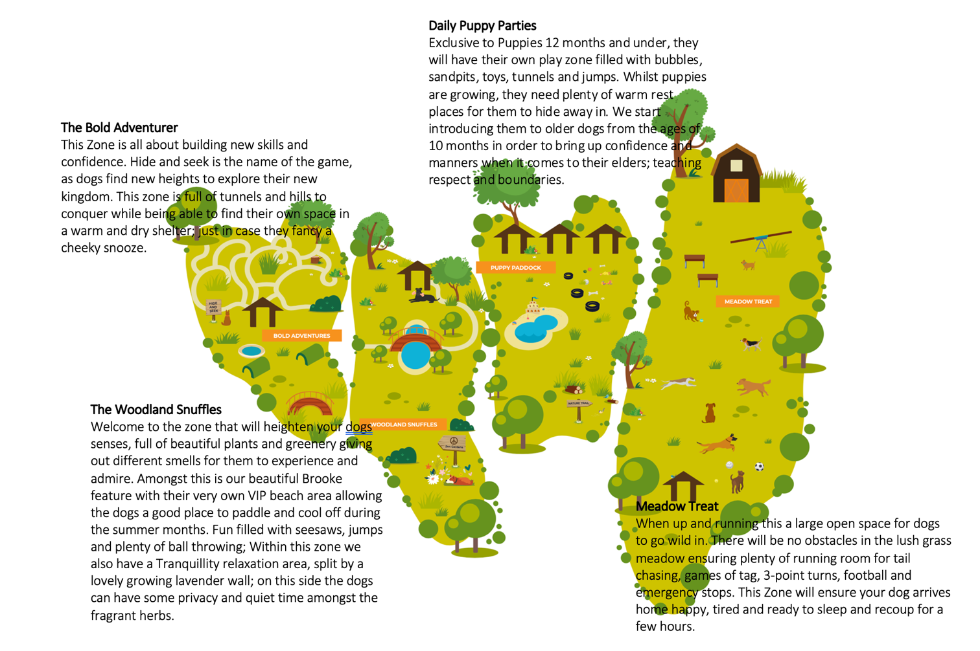

Payment plan

As outlined in the T & Cs and the website, Mocha and Maisy Kemble Limited is a membership scheme with a 1 session per week minimum entrance level membership program.

Mocha and Maisy Doggy Playschool runs for 51 weeks in the year and as such calculates all payments based on 51 weeks a year. Christmas week is taken off.

Example of monthly fee structure

1 full day session per week £35 = 51 weeks x £35 = £1,785 per year / over 12 mths = £178.50 (inclusive of VAT) per month fee
2 Full day sessions per week £68 = 51 weeks x £34 = £3,468 per year / over 12 months = £346.80 (inclusive of VAT) per month fee

We require a £60 set up fee and then a Standing Order set up or Direct Debit for the monthly fee depending on the membership requirement

Bank Details

Account : Mocha And Maisy – Kemble Limited
Account Number: 61961834
Sort Code: 608371

If required:

IBAN: GB56SRLG60837161961834

Reference for your Standing Order / Direct Debit should be your dog’s name please

